Top of Form


New owner beaming over Harbor Light
By Kathleen Edgecomb
Published on 10/10/2009 in Home »Region »Region Main Photo

New London Maritime Society receives deed to 206-year-old structure
New London — After 10 years of research and persistence, the New London Maritime Society has become the proud owner of the 206-year-old New London Harbor Lighthouse.
DAY FILE PHOTO
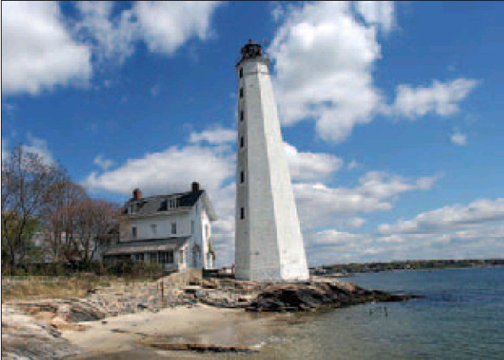
The iconic New London Harbor Lighthouse is used as a symbol of the city. The New London Maritime Society is the lighthouse’s new owner.
New London - After 10 years of research and persistence, the New London Maritime Society has become the proud owner of the 206-year-old New London Harbor Lighthouse.
The U.S. General Services Administration handed over the deed to the Pequot Avenue property on Tuesday. The paperwork was filed in City Hall on Thursday.
”We certainly didn't want to leave a beautiful and interesting structure like that to go to waste,'' said Benjamin Martin, who along with George Sprecace doggedly kept pursuing ownership of the historic building.
”It is singularly a good example of that type of lighthouse,'' Martin said. “It still has value as a lighthouse, helping ensure mariners' safety.''
Ten years ago, Martin and Sprecace, both officers in the society, proposed the society try to get ownership of the iconic lighthouse, which is used on advertising for local real estate firms, painting contractors and other businesses, and as a symbol of the city on tourist information.
Harbor Light was one of 19 lighthouses across the country that the federal government was offering to suitable owners because it no longer wanted to be responsible for their upkeep.
Susan Tamulevich, director of the Custom House Maritime Museum, said Friday the lighthouse will be used in educational programs offered by the Custom House.
”We will be the custodians,'' she said, adding that plans include preserving, restoring, securing and maintaining the lighthouse. Eventually, the 89-foot tall lighthouse will be open for small guided tours.
Martin admitted Friday he never thought acquiring the lighthouse would take this long.
”It's in fairly reasonable shape,” he said. “It's a little crusty around the edges, but once the edges are straightened out, it will be fine.”
The Coast Guard will continue to operate the beacons inside the lighthouse.
Martin said he would like to create an endowment for the annual upkeep of the lighthouse. Tamulevich said the group is looking for volunteers, especially those versed in fundraising.
k.edgecomb@theday.com
"New London-CT"
Total 1 images.

The iconic New London Harbor Lighthouse is used as a symbol of the city. The New London Maritime Society is the lighthouse's new owner.

Bottom of Form

