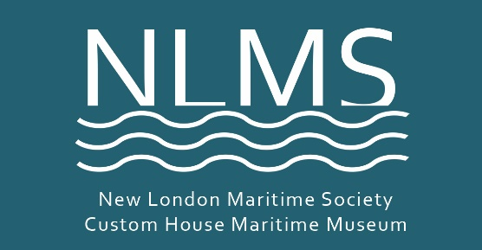
Please make a 100% tax deductible donation to the
2018 New London Maritime Society
ANNUAL FUND
Dear friends and supporters, this is the most heart-felt letter I have written in the 10 years that I have been executive director of your maritime society. I cannot thank you enough for your unwavering support.
It was touch-and-go financially this year as we finally resolved all legal issues with Harbor Lighthouse. Together we persevered and won - establishing the inalienable right for you and future generations to visit this historic beloved local landmark. In 2018 your donations allowed our programs for students and seniors to blossom. You enabled the creation of new and more-intimate opportunities to visit inside Ledge Lighthouse. And for the first time in 185 years, the custom house’s four interior gutters (in the attic) have been replaced and the roof leaks stopped!
Your generosity is what keeps us afloat. Annual Fund contributions make up 20% of the New London Maritime Society operating budget. Your gift to NLMS makes an immediate impact on our ability to enhance our educational offerings and preservation work both at the museum and out in the community.
Help us create a bright new year of adventurous programming at the Custom House. In 2019, for the first year, all three floors of the museum will be open to the public. New exhibitions – like woolies in 2018 – will surprise, inform and delight. If you make a gift to the annual fund, the season ahead – the maritime society’s 36th – is certain to bring new creative ways for the community to celebrate our maritime life and heritage.
Please use the envelope and give today! Checks may be made out to NLMS, 150 Bank Street, New London, CT 06320. Help us end the year on solid financial footing by donating to our Annual Fund.
With gratitude for your support, -- Susan
PS: 'How will we know it's us without our past?' --John Steinbeck. Please brighten the new season with a gift to New London Maritime Society by December 31.

Many thanks, and best wishes for the Holidays.
TRUSTEES: Lloyd Beachy, Andrew Blacker - Vice President, Christina Corcoran, Edward Cubanski - President / Board Chairman, Russell DeMarco, John Desjardins, R.N., B.S.N., Josie Esposito, Robert Groves, Jennifer Hillhouse, William LaRoue, PhD - Head Docent., Carolyn Leuze, Alan Lyon - Treasurer, Morgan McGinley, Robert A. Pittaway, George Sprecace, Susan Tamulevich - Executive Director, Ed Uditis, Kathy Walburn – Secretary, Ted Webb. HONORARY TRUSTEES: Lonnie Braxton, II, Esq., James Fleishell, Nicholas Hanke, Kathleen Jacey, Nick Korstad, Frank Racette, James Reyburn, Richard Salews, Greg Stone, George H. White. LIBRARY STAFF: Brian Rogers - librarian, Laurie Deredita - librarian, Eugene MacMullan - paper conservator. VOLUNTEER COORDINATOR: Linda Roselund.
The New London Maritime Society is a 501(c)(3) nonprofit charitable organization, tax ID #06-10866688. NLMS receives no regular funding from any other organization. We rely entirely on donations and the money raised from visitors to the Museum. There is only one staff member; the museum is run by a dedicated band of volunteers who give generously of their time.

You Help NLMS Programs to Thrive!
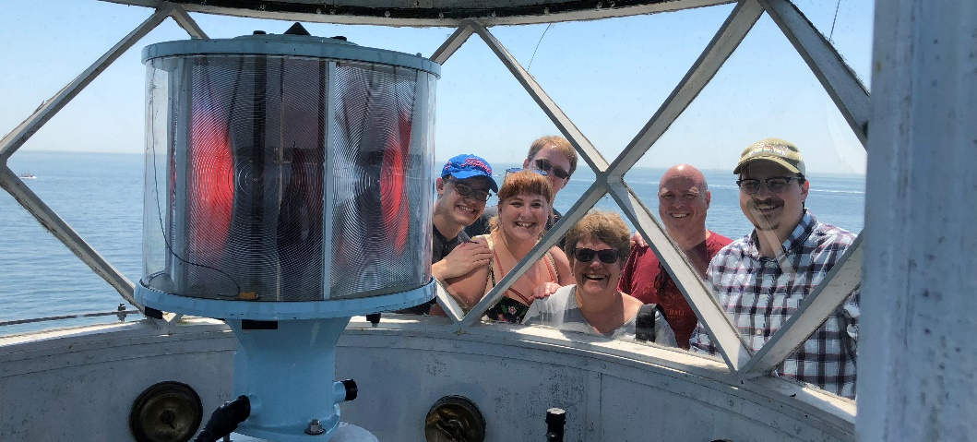

__ $1,000 Whale __$750 Harbor Seal __$500 Oystercatcher __$250 Gull __$100 Scallop __$50 Quahog

My contribution is $____________

Name __________________________________________Date_______________

Business (if applicable)________________________________________________

Address____________________________________________________________

City_____________________________ State___________ Zip ______________

Email____________________________________ Phone____________________

Does your employer match this gift? Employer___________________________

Check (by mail) ___ Make out check to 'New London Maritime Society' or NLMS

Credit card (circle one): Visa / Master Card / American Express / Discover

Credit card #_______________________________ Exp._________ Code______

I'd like to Leave a Legacy. Please contact me ____ phone__________________

Questions? Contact Susan at 860-447-2501, nlmaritimedirector@gmail.com
You also may make a donation online at nlmaritimesociety.org.

nlmaritimesociety.org
New London Maritime Society 2018 ANNUAL FUND, 150 Bank Street, New London, CT 06320

